ETHNOMEDICINAL VALUE OF ANGIOSPERMIC PLANTS OF AMBALA CANTT: A SURVEY
Sachin Sharma & Jitesh Vats
BSc III (Biotechnology)
Dept. of Botany, S.D.College Ambala Cantt
INTRODUCTION
Ethno botany is the study of a region's plants and their practical uses through the traditional knowledge of a local culture and people. An ethno botanist strives to document the local customs involving the practical uses of local flora for many aspects of life, such as plants as medicines, foods, and clothing.
Richard Evans Schultes is often referred to as the "Father of Ethno botany". According to him, ethno botany simply means investigating plants used by primitive societies in various parts of the world.
Change is the nature of time and with changing time the lifestyle of humans is changing dramatically. Now it is an era of latest equipment, competition for better lifestyle, fame, success and much needed money. We rarely pay attention to our health, for example, if someone is suffering from a common cold or cough, one would rather prefer to have medicines instead of waiting for the back response of our body. For any common illness there are thousands of medicinal brands which offer quick cure but cause some major side effects to our body but we don’t pay much attention to them. We are just keen to have relief for that time. Who cares what will happen later on.
But we Indians are quite lucky as comparison to people of other countries. We have a large number of documents available for herbal remedies. It is not just the documentation but also we Indians are practicing the medicinal use of plants and their parts i.e. leaves, roots, fruits, stems etc. in our Ayurveda for different types of illnesses. Whether taken orally or applied externally, these traditional medicines play resilient role. Some of them show results instantly but some take time. They have almost negligible side effects since they are natural and are easy to digest.
So we can say ethno botany is a way to remain fit without harming the natural metabolism of our body.
- Survey
To know the ethno medicinal value of variety of plants or plant products a survey was conducted in Ambala and nearby areas from July 2016 till October 2017 under the guidance of our teachers Dr. Divya Jain and Prof. Sumit Chhibber. For the ethno medicinal value of plants interviews were conducted with local vaids and herbal medicine practitioners. Help was taken from the books and research journals.

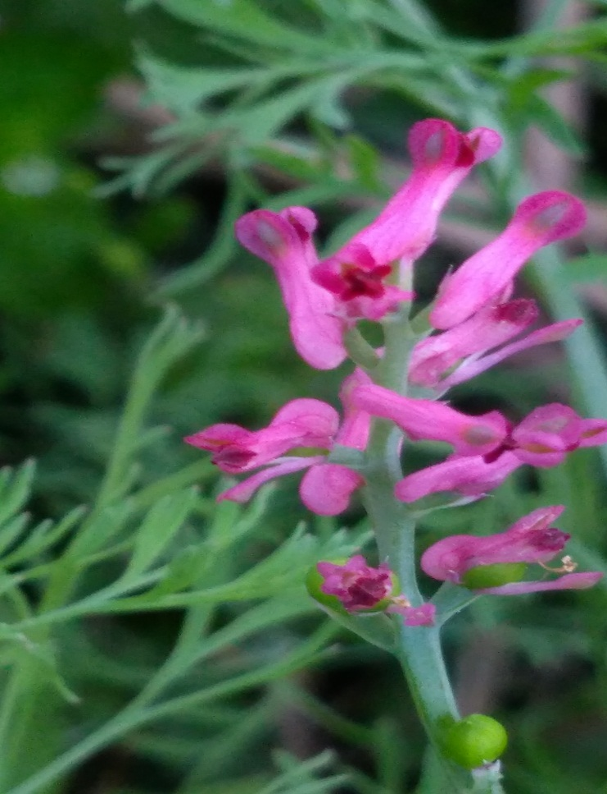
- Fumaria officinalis
Kingdom :- Plantae
Class :- Dicotyledons
Order :-Parietales
Family :-Fumariaceae
Genus :-Fumaria
Species :-officinalis
Location :-Babyal , S.D. College , Ambala Cantt.

Common Names: Common fumitory, drug fumitory, hedge fumitory, earth smoke, wax dolls, fumaria.
Habitat: Fumitory is originally native to Europe and North Africa, but has been introduced to Asia, North America, and Australia.
Botanical Description: Fumitory is a 10-50 cm tall, annual herbaceous plant that is usually classified in the poppy family (Papaveraceae) but has sometimes been placed in a plant family of its own (Fumariaceae).
The plant has smooth, thin and soft stems with gray-blue leaves. The flowers are purple-pink and bloom from April to October. The fruits are spherical nuts (achene).
Plant Parts Used: The entire plant, except the root, has been used in herbal medicine.

Health Benefits and Medicinal Applications of Fumitory
- The plant material is collected at the beginning of the flowering period and dried for later use in extracts, teas, pills (capsules), eye lotions and tinctures.
- The herb has a bitter and salty taste, and the plant juice has a strong distinctive smell.
- Fumitory is a plant that has followed humans as a weed in fields and gardens for centuries. It has been known since antiquity and was described in herbals from the middle Ages. It was also used in folk medicine as a treatment for jaundice.
- Fumitory has for a long time been used to treat skin ailments such as rash, chronic eczema, psoriasis, scabies and acne. These uses may be due to the purifying and detoxifying effect the herb is believed to have on the kidneys and liver, but it may also be due to the content of the fumaric acid.
- The herb is sometimes recommended as a remedy for hemorrhoids by adding the dried herb in a bath water. It’s extraction in hot water is used as an eye wash for conjunctivitis.
- In ancient times, fumitory was regarded to have magical powers. The plant was burned in bonfires because it was believed that the smoke from the plant could protect against witchcraft and expel evil spirits.

Possible Side Effects and Interactions of Fumitory
- Fumitory should only be used in small amounts. The herb has a toxic effect in large doses and can cause severe diarrhea, muscle cramps, and breathlessness.
- If the herb is intended for therapeutic reasons is advisable to do so under the care of a licensed herbalist or other health care provider knowledgeable about medicinal herbs.

- Argemone mexicana
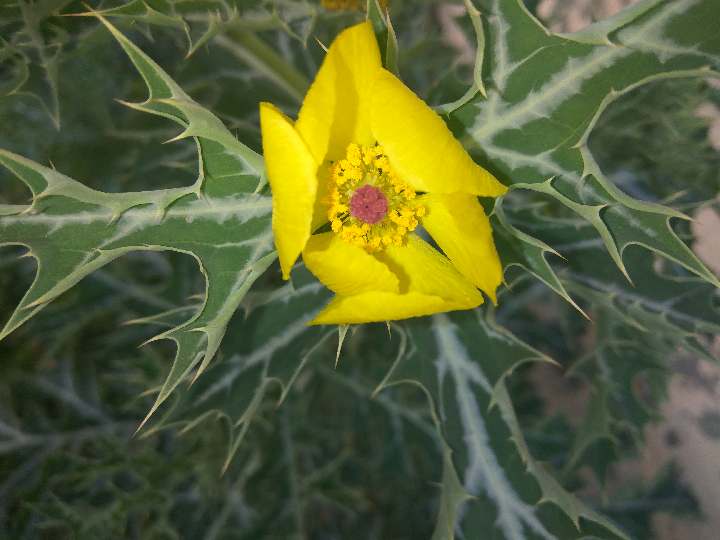
Kingdom :- Plantae
Class :-Dicotyledons
Order :-Parietales
Family :-Papaveraceae
Genus :-Argemone
Species :-mexicana
Location :-Babyal, Anandnagar , Convoy Park , Mahesh nagar , Ambala Cantt .

Common name: - Satyanashi, Mexican poppy, Prickly Poppy
- Mexican Prickly Poppy is a prickly, hairless, branching herb with yellow juice and showy yellow flowers.
- The Sanskrit name svarnakshiri is given because of the yellow juice (Svarna - Gold; Kshiri - Juice ).
- In India it is introducd and naturalised and occurs as wasteland weed in almost every part of India.
- In many parts it is reported as crop weed also. The height of this plant varies between 1-4 ft. Leaves are thistle like, stem-clasping, oblong, multiply cut, spiny, with white veins.
- Flowers occur at the end of branches, yellow. 2.5-5.0 cm across. Fruits are capsules. The plants are toxic to animals and cattle. Flowering all year.

Medicinal Uses

- For Skin Infections:
The yellow latex has anti-bacterial properties. If you break any part of the plant, yellow latex will flow out. Take a cotton bud and dip it in the latex and apply on the affected area. The whole plant is covered with thorns so please be careful while extracting the milk. You can use the latex for skin infections like skin ulcers, itching, eczema and boils.
- For Healing Wounds:
Argemone mexicana leaf extract is great for treating wounds that takes a long time to heal. To use, take the leaves (carefully cut the leaves from the plant without getting hurt) and pound in a mortar and pestle and extract the juice and apply on the affected area. The leaves can be pounded into a paste and applied as a poultice too. The leaf poultice can be used for insect bites also.
- Seeds As a Mosquito Repellent:
Since the mosquito repellents that we get in the markets come with many side effects if used regularly, it is a good idea to get to know plants that have strong larvicidal properties. Argemone mexicana seed extract have strong larvicidal properties and can be used as a mosquito repellent.
- Impotency and infertility
Powdered root of satyanashi taken with misri is advised to cure impotency.
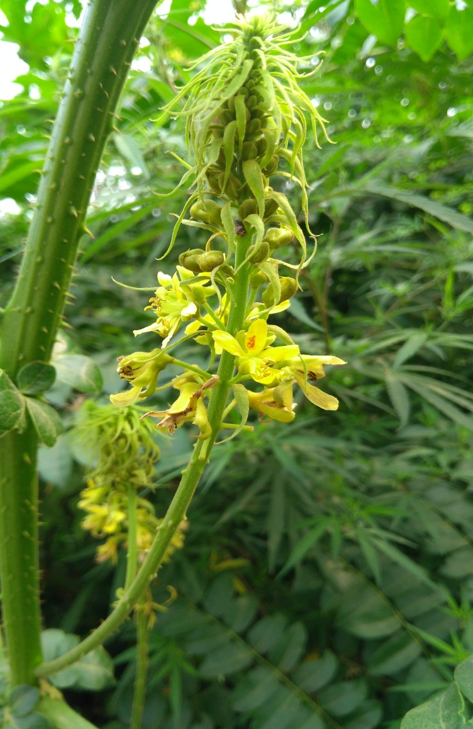
- Caesalpinia bonduc
Kingdom :- Plantae
Class :-Dicotyledons
Order :-Rosales
Family :-Fabaceae
Genus :-Caesalpinia
Species :-bonduc
Location :-Babyal Road nirmalcomlex, Ambala Cantt.

Common name: Yellow Nicker, Gray nicker, nicker seed, bonduc nut, Fever nut, nicker bean, Kantkarej .
- Yellow Nicker is a large, thorny, straggling, shrub which behaves like a strong woody climber, taking support of trees.
- The branches are armed with hooks and straight hard yellow prickles.
- Leaves are large, double compound, with 7 pairs of pinnae, and each with 3-8 pairs of leaflets with 1-2 small recurved prickles between them on the underside.
- Flowers are yellow, in dense long-stalked racemes at the top.
- Fruits are inflated pods, covered with wiry prickles.
- Seeds are 1-2 per pod, oblong or globular, hard, grey with a smooth shiny surface. The hard and shiny seeds are green, turning grey.
- They are used for jewellery.

Medicinal uses:-
- Caesalpinia bonduc is used in traditional medicine system for treatment of wide variety of ailments. The seeds of plant have anthelmintic, fever reducing, abortion stimulating, menstrual flow improving, and urine stimulating, adaptogenic, antimicrobial, muscle contractile and abdominal pain relieving properties.
- They also checks nausea and vomiting when used in combination with clove or black pepper.
- For fever, the seed powder is mixed with equal part black pepper powder. The prepared mix powder is taken in dose of 15-30 grains by adults and 3-4 grains by children.
- In liver disorders, seed powder is administered with goat milk.
- In case of abdominal pain 2-3 seeds of plant are crushed to make powder and administered orally.
- The seed powder reduces blood sugar level and taken with water for treatment of diabetes.
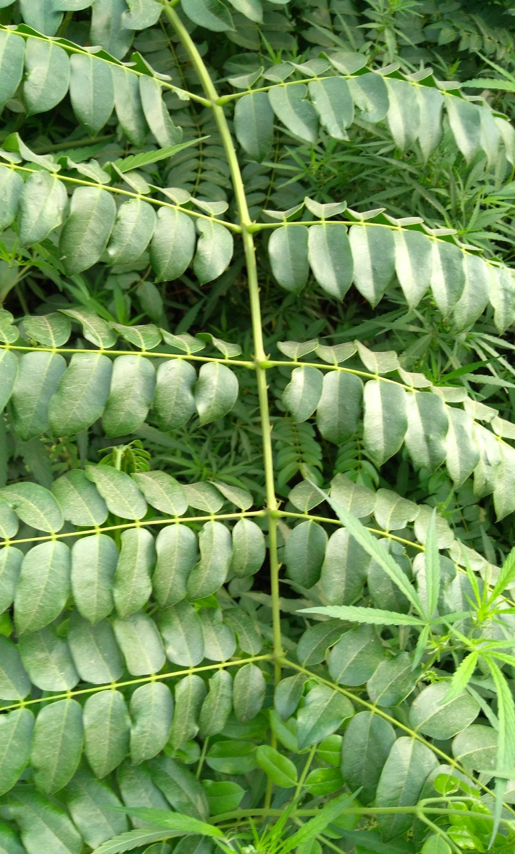
- Seed and long pepper powders with honey has good expectorant effect and given in cold, cough and respiratory illness.

- The leaves of Caesalpinia bonduc plant are also used to treat diarrhoea in animals. Handful of leaves is given to animal in paste form till loose motions are stopped.
- Boiled leaves can be used for gargling to relieve sore throat.

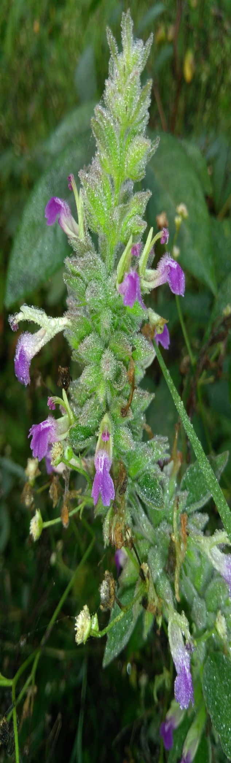
- Anisomeles indica
Kingdom: Plantae
Class : Dicotyledons
Order :Lamiales
Family : Lamiaceae
Genus : Anisomeles
Species : indica
Location: - Babyal road Power house, Ambala Cantt .

Common name: Indian Catmint, Malabar catmint , Kala bhangra, Gobara .
- Catmint is a strongly aromatic, large, perennial herb growing up to 2 meters tall .The stems often become more or less woody and persist.
- The plant is widely used as a medicinal herb, mainly gathered from the wild, and is also cultivated throughout its distribution area both as an ornamental and for the essential oil in its leaves.
Medicinal uses:-
- An infusion is useful in affections of the stomach and bowels, and in catarrh and intermittent fevers; and that the juice of the leaves is administrated to children for colic, dyspepsia, and fever caused by teething.
- A decoction of the plant is an excellent fomentation for is used externally as an ointment in rheumatism arthritis.
- It is a powerful astringent, carminative, febrifuge and tonic.
- The leaves yield an essential oil which shows antimicrobial activity against Bacillus anthracis, Proteus vulgaris, and Escherichia coli.
- The plant is used in the treatment of rheumatism, colds, fevers, abdominal pain, skin sores, and snake bites.
- Crushed leaves applied to neck of bullock to cure inflammation caused by cart pulling.
- The essential oil from leaves is used in uterine affection.
- Root is anti- allergic; cures sores and ulcers of the mouth.
- Leaf juice is given for fever and whooping cough of children.

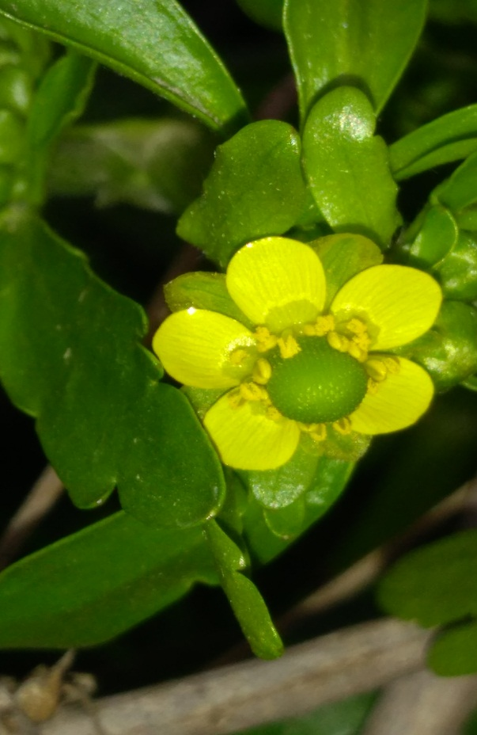
- Ranunculus sceleratus
Kingdom :- Plantae
Class :-Dicotyledons
Order :-Ranales
Family :-Ranunculaceae
Genus :-Ranunculus
Species :-sceleratus
Location :-Babyal, Anandnagar, Mahesh nagar, Ambala Cantt.

Common name: Cursed Buttercup, Poisonous buttercup, Celery-leaved buttercup
- Ranunculus sceleratus is an annual herb growing up to half a meter tall.
- The leaves are more or less glabrous (hairless) and have small blades each deeply lobed or divided into three leaflets.
- They are borne on long petioles. The flowers are 5-10mm across with five or fewer yellow petals a few millimeters long and reflexed sepals. The fruit is an achene borne in a cluster of several.
- When chewed, it inflames the tongue and produces violent effects.

Medicinal uses:
- The celery-leafed buttercup is one of the strongest acting of our native plants.
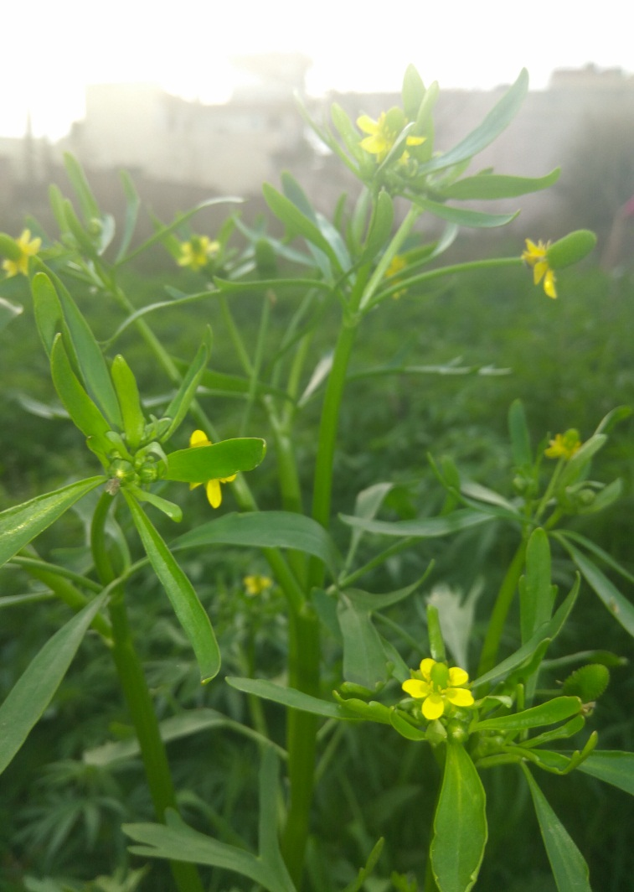
- The whole plant is acrid, mildly pain-relieving, and antispasmodic, induces sweating, promotes or assists the flow of menstrual fluid.
- The leaves and the root have been used externally for rheumatism.
- The seed is tonic and has been used in the treatment of colds, rheumatism and excessive ejaculation.

Precautions
- When bruised and applied to the skin it raises a blister and creates a sore that is difficult to heal.
- If chewed it inflames the tongue and produces violent effects. If used medicinally, the herb should be used fresh since it loses its effects when dried.

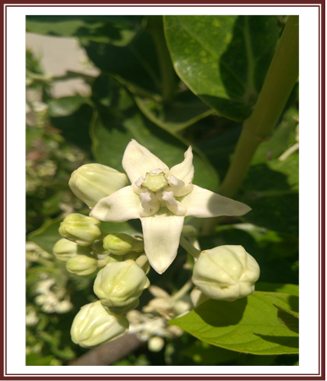
- Calotropis gigantea
Kingdom :- Plantae
Class :-Dicotyledons
Order :-Gentiales
Family :-Asclepiadaceae
Genus :-Calotropis
Species :-gigantea
Location :-Babyal , Anandnagar , Convoy Park , Ambala cantt .
Common name :- Giant milkweed, Madar , Aak , rubber bush

Calotropis gigantea or Madar plant is a common shrub that grows up to 4 meters in height. The lavender or white flowers have a waxy appearance, with ridged edges. Each flower has five petals and a small crown. This crown holds the stamens. The sepals or petals of the flower remain arranged in a whorl do not overlap but only touch each other. The leaves are light green, subsessile, ovate and cordate at the base. The stem is milky. It can be found in open areas, wastelands, and arid areas throughout in India.

Medicinal uses:-
- The milky exudate of the plant is poisonous. You can purify it and use it for medicinal purposes. The herb is very strong and has an astringent action.
- It is used for treating conditions such as excessive salivation.
- You can treat hemorrhoids with this Madar herb. Apply the latex on the piles topically.
- People use it to treat anorexia.
- It has carminative effect. You can cure the gas in the intestines with this plant extract.
- It is good for the digestive system. It is light and easy to digest and improves digestive strength.
- It improves sexual health. The madar plant extract preparations make tonics for sexual health. People use this herb as an aphrodisiac.
- Good for coughs. You get relief from coughs and asthma by using the madar herb. It is a good expectorant and finds use in treating respiratory disorders.
- Good anti-inflammatory nature. The anti-inflammatory nature of the plant helps us treat inflammatory diseases such as gout and rheumatism. Warm the crushed leaves and apply it on painful joints for immediate relief.
- Helps to get rid of blemishes of the skin: You may apply the latex of the plant mixed with haldi to the facial skin to get rid of discolouration and blemishes.
- Treat Ear pain. To get a cure for ear disorders or pain in the ear, use yellow Aak leaves.
- It helps bowel movement: The preparations of the Madar plant help ease constipation.
- Useful as expectorant. The preparation of the Madar tree will help relieve coughs and cold .

- Antidote for snake poison. During the olden times, people chewed the leaves of the Calotropis gigantea plant and applied the latex over the wound of a snake bite.

- Relief for a toothache. We can apply the latex on the gums to get relief from a toothache.

- Treat sexually transmitted diseases. People use the white flowers of the Madar plant for treating diseases such as syphilis.

- Good antifungal property: You can treat diseases such as Candida by using the madar plant preparations. The medicine can prove poisonous if overdosed.

Precautions
The latex is poisonous. It can cause temporary blindness, so you should take care when you handle this herb.

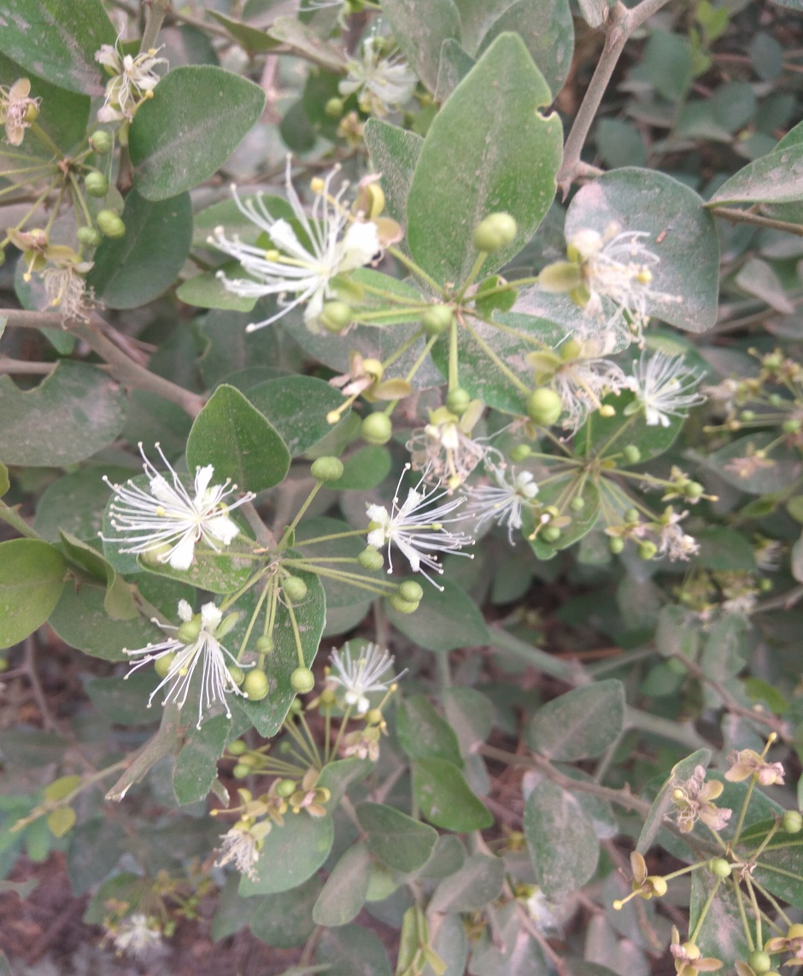
- Capparis sepiaria
Kingdom :- Plantae
Class :-Dicotyledons
Order :-Parietales
Family :-Capparidaceae
Genus :-Capparis
Species :-sepiaria
Location :-Babyal , Ambala cantt.

Common name: Wild Caper Bush, Tarabtab

- Tarabtab is a woody vine, growing from 1.5 to 3 meters in height. Young branches are hairy.
- Spines are short, sharp, and recurved. Leaves are oblong-ovate to elliptic-ovate, 2 to 8 centimeters long, with a shallow notch at the tip.
- Flowers are grouped 5 to 15 in axillary and terminal, sessile or short-peduncled umbels, with the slender pedicels 1 to 1.5 centimeters long.
- Sepals are green and concave. Petals are oblong, white, and 7 to 8 millimeters long. Fruit is rounded, 8 t 10 millimeters in diameter, nearly black when mature, and one-seeded.
Medicinal Uses
- Used as febrifuge, alterative, and tonic.
- Used for skin diseases.
- In India, traditionally used as blood purifier, tonic and appetizer.
- Fresh bark, stem, and leaves are used to treat eczema, dandruff and to reduce body heat.
- Flowers leaves, and roots used in cough and toxemia.
- Root powder used for inflammation and diseases of the muscles; also used for snake bites.

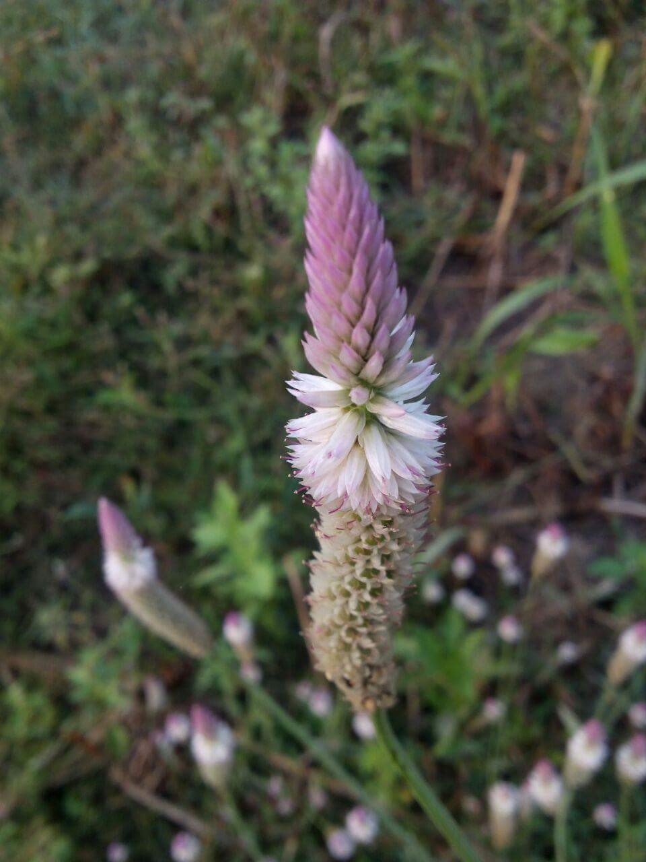
- Celosia argentea var. spicata
Kingdom :- Plantae
Class :-Dicotyledons
Series :-Curvembryae
Family :-Amarantaceae
Genus :-Celosia
Species :-argentea var. spicata
Location :-Babyal, Patel park, Ambala cantt.
Common name: Silver Cockscomb, Flamingo Feathers, Wheat Celosia

- Silver cockscombs are erect, branching plants with oval or lance-shaped, strongly veined leaves 2-6 in long and hundreds of tiny flowers packed in dense spikes of silver-white flowers which usually stand above the foliage.
- They are beautiful plants with soft, dense feathery spikes, produced in profusion.

Medicinal uses:-
- The flowers and seed are astringent, haemostatic, ophthalmic, parasiticide and poultice.
- They are used in the treatment of bloody stool, hemorrhoid bleeding, uterine bleeding, leucorrhoea, dysentery and diarrhoea.
- A liquid extract from the leaves and flowers is used as a body wash for convalescents.
- The leaves are used in the treatment of infected sores, wounds and skin eruptions.
- The whole plant is used as an antidote for snakebites.
- The roots are used in the treatment of colic, gonorrhea and eczema.
- The juice of the seeds forced into the nostrils is a cure for epistaxis.
- In Indian folk medicine, used for diabetes. Seeds traditionally used for treatment of jaundice, gonorrhea, wounds and fever.

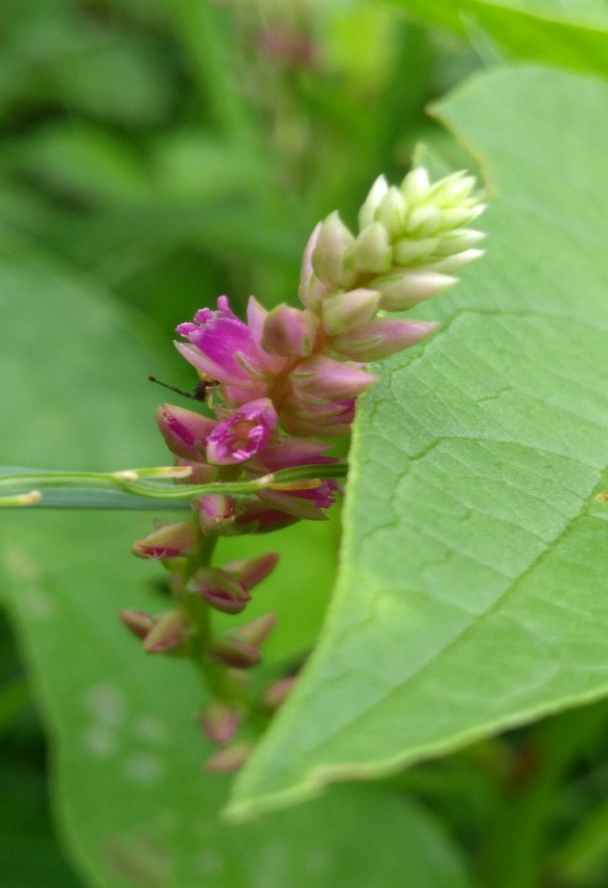
- Digera muricata
Kingdom: - Plantae
Class : -Dicotyledons
Series :-Curvembryae
Family : - Amarantaceae
Genus : - Digera
Species : - muricata
Location: - S . D. College Ambala Cantt .
Common name: False Amaranth

- False Amaranth is an annual herb, growing to 20-70 cm tall. It can be seen growing wild in waste areas.
- Stems are simple or branched from the base, nearly hairless. Alternately arranged leaves, 1-9 cm long and 0.2-5 cm broad, are narrowly linear to broadly ovate.
- Leaf stalks are long, up to 5 cm, base is narrowed, and the tip pointed. Flowers are borne on slender spike-like racemes, which can be as large as 30 cm long.

Medicinal uses:-
- In India, the young leaves and shoots of False Amaranth are made into curries, or the entire plant is boiled and seasoned.
- Though almost all of its parts are used in traditional systems of
medicines, leaves, roots and shoots are the most important parts which are used medicinally.
- Wide numbers of phytochemical constituents have been isolated from the plant which possesses activities like antibacterial, antifungal, diuretic, laxative, free radical scavenge activity, anthelmintic, and various other important medicinal properties.
- The crushed plant is used as mild astringent in bowel complaints.
- Flowers and seeds used in the treatment of urinary discharges.

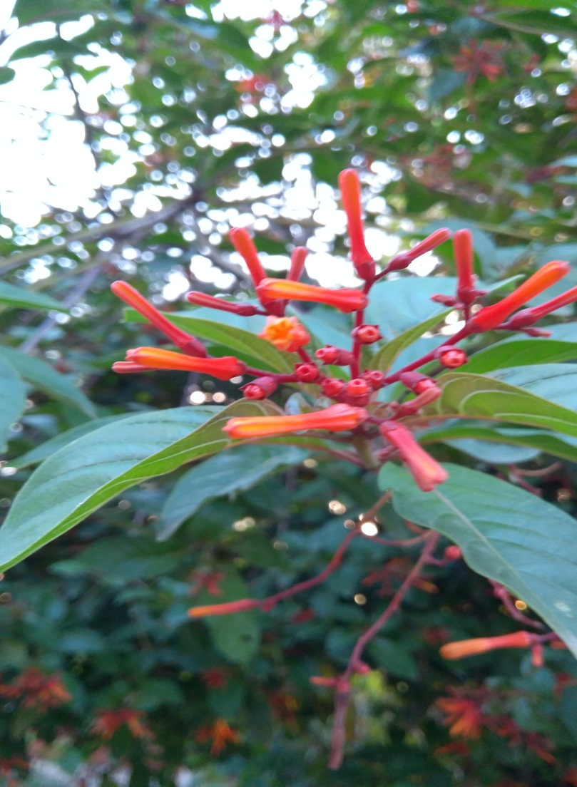
- Hamelia patens
Kingdom :- Plantae
Class :-Dicotyledons
Order :-Rubiales
Family :-Rubiaceae
Genus :-Hamelia
Species :-patens
Location :- Mall road , S.D.College , Ambala cantt.

Common names: - fire bush, humming bird bush, scarlet bush, and redhead.
- Fire bush has orangish-red tubular flowers, which recruit humming birds and butterflies for pollination. The corollas vary greatly in length, making them attractive to a wide range of pollinators. The fruit is a small dark red berry, turning black at maturity.
- The Fire bush is probably one of the most commonly planted unknown edibles. They are usually arranged in the landscape to attract butterflies and migratory or resident humming birds. However the fruit is edible and the plant has a long history of medicinal and industrial uses.
- It is showy, fast-growing, and evergreen, stays small, attracts birds and insects and provide an edible fruit.
- It blossoms all year with tubular flowers, reddish-orange or scarlet. Even the stems of the flowers are red.
- The fruit is a juicy berry with a lot of little seeds. It ripens from green to yellow to red then black.
- It can be eaten out of hand, made in to a syrup or wine, a particular favorite in Mexico.
Medicinal Uses
- Fire bush is used to treat a variety of skin problems including, sores, rashes, wounds, burns, itching, cuts, skin fungus, and insect stings/ bites.
- In the lab animal studies with Fire bush leaf extracts showed analgesic, diuretic, and hypothermic actions.
- External use showed significant anti-inflammatory activity.
- The bush also has antibacterial and antifungal properties against a wide range of fungi and bacteria in several. Also, incisions bathed with plant juice healed faster and stronger than no bathing or application of petroleum jelly.
- The industrial use of the plant comes from it high amounts of tannins.

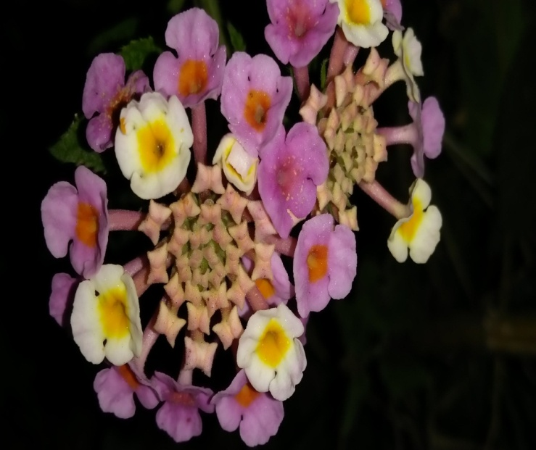
11. Lantana camara
Kingdom :- Plantae
Class :- Dicotyledons
Order :-Lamiales
Family :-Verbenaceae
Genus :-Lantana
Species :-camara
Location :-Babyal, Mall road , Convoy Park , Ambala cantt
Common names:
Lantana weed, yellow sage, tick berry, white sage and wild sage.
- Lantana camara is a perennial flowering plant that is often used as a potent natural herbal remedy that can be used to treat various diseases.
- The flowers usually have very tiny yet beautiful petals that cluster together. It is also important to note that these flowers often come in different colors. The herb’s flowers, leaves, and roots are all used to make potent herbal remedies. The herb’s green berries (seeds) are, however, always avoided due to their toxic nature.
- Lantana camara has small tubular shaped flowers which each have four petals and are arranged in clusters in terminal areas stems.
- Flowers come in many different colours including red, yellow, white, pink and orange which differ depending on location in inflorescences, age, and maturity.

Medicinal Uses:

- Lantana camara has been widely used in the traditional herbal medicine field to manage and even cure various common diseases.
- These include asthma, ulcers, cancer, leprosy, skin itches, measles, rabies and chicken pox just to name a few.
- The potent herb can be topically applied to alleviate various common skin disorders, especially measles, chicken pox, scabies and skin fungus. There are scientific findings that indicate that Lantana camara can be used to heal wounds due to its fast-acting antiseptic and antimicrobial properties.
- The potent natural herbal remedy can also be taken to improve overall digestive system health. L. camara contains powerful antimicrobial compounds that can be used to get rid of any harmful bacteria that can be found in the stomach. Apart from that, this amazing natural herbal remedy can also be used to alleviate multiple stomach disorders including bloating, indigestion, stomachache, diarrhea, and ulcers.
- The leaves of the Lantana camara plant contain potent insecticidal properties. That can be used to repel and even kill harmful insects. L. camara can then be used to prevent malaria due to its ability to repel and even kill mosquitoes.
- The Lantana camara herb can be used to alleviate various common respiratory issues. The tea made from the leaves of the potent herbal remedy provides an almost immediate relief from coughs, colds, and flu.

Precautions:
The L. camara herb can be used by humans without experiencing any severe side effects. However, various scientific studies indicate that ingesting berries produced by the plant, especially the green unripe ones can be quite toxic.

- Pergularia daemia
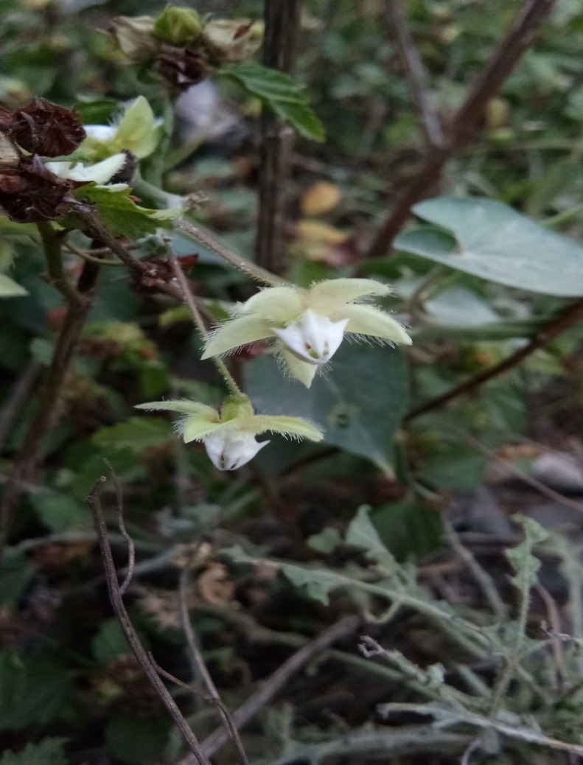
Kingdom :- Plantae
Class :-Dicotyledons
Order :-Gentiales
Family :-Asclepiadaceae
Genus :-Pergularia
Species :-daemia
Location :-Babyal, Patel park, Boh Ambala cantt.

Common name:-Utaran, Sagovani, Aakasan, Gadaria Ki bel, Jutak .

- Pergularia daemia is a perennial twining herb, foul-smelling when bruised and with much milky juice, stem hairy.
- Leaves are thin, broadly ovate, heart-shaped or nearly circular, hairless above, velvety beneath.
- Greenish yellow or dull white and sweet-scented flowers are borne in lateral cymes which are at first corymb-like, afterwards raceme-like.
- The five petals are hairy and spreading outwards.
- Corona outer and inner, outer truncate, inner curved high over the staminal column, spur acute.
- Fruit is a follicle, with soft spines all over and a long beak. Seeds are densely velvety on both sides.
- Flowering: August-February.

Medicinal uses:
- Pergularia has been used in folk medicine for the treatment of liver disorders.
- The whole plant is used as an anthelmintic, antiseptic, antivenin, increases menstrual flow, emetic expectorant and expectorant.
- The leaves are useful in leprosy and hemorrhoids.
- In addition dried leaves are used as an anti-rheumatic, asthma, amenorrhea, dysmenorrheal, bronchitis, whooping cough, heals cuts and wounds and finally to facilitate parturition.
- The stem bark of this plant was a good remedy for cold, it is also used to treat malaria and the twig is used as an antipyretic.
- Dried roots are used as an emetic, bronchitis and used for cough, asthma and constipation, while the fresh roots used as an abortifacient and used to treat gonorrhea.
- In Ayurveda system of medicine this plant is used for delayed child birth, amenorrhea, asthma, snake bite, rheumatic swellings and also to treat post-partum hemorrhage

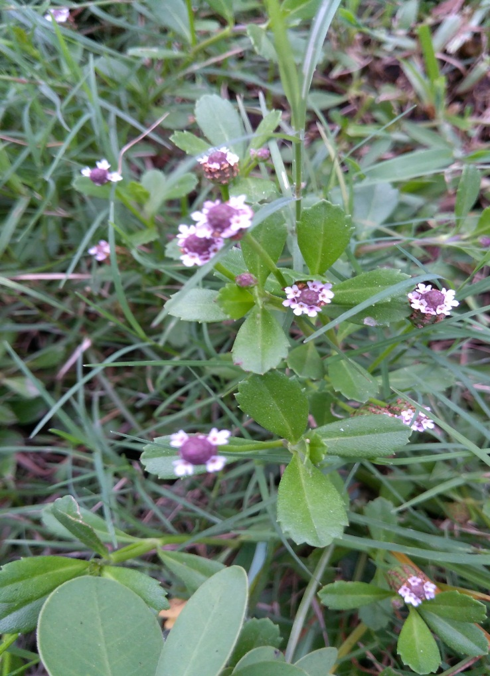
13. Phyla nodiflora
Kingdom :- Plantae
Class :-Dicotyledons
Order :-Lamiales
Family :-Verbenaceae
Genus :- Phyla
Species :-nodiflora
Location :- Mall road , patel park , Ambala cantt.

Common name: Frog Fruit, Turkey tangle, Creeping Lip Plant, Lippia

- It is grows in a groundcover or turf like manner, and is often present in yards.
- The inflorescence consists of a purple-coloured center encircled by small white-to-pink flowers. The flower takes on a match-like look, which is why the plant is called match weed.
- The leaf arrangement is opposite. Each leaf has one to seven teeth on each edge starting at the widest point and continuing to the tip.
- In India, it occurs in almost all states at lower altitudes.

Medicinal uses:-
- Plant decoction is given in uraemia.
- Fresh juice is applied to bleeding gums.
- Infusion of leaves and tender stalk is given to children in indigestion and to women after delivery.
- In India, used as demulcent in gonorrhea. Also, paste of leaves applied to swellings and wounds.
- Toasted tender stalks and leaves, in infusion, used for children’s indigestion.
- Juice of roots used for gastric problems.
- Used for treatment of hookworms.
- Used as by women after childbirth.
- It is for fever and as diuretic.
- Applied as paste to promote suppuration.
- Infusion used in colds with fever.
- Poultice of fresh plant used to hasten ripening of boils.
- Used for liver disorders, dandruff control, and indigestion in children.
- Plant used for joint pains, constipation, ulcers, boils, swollen cervical glands, and gonorrhea.
- Used for asthma, bronchitis, diseases of the heart, blood, and eyes.
- Plant vapors inhaled to treat coughs and colds. Root juice used for gastric problems.
- Paste or poultice of plant applied to swollen cervical glands, erysipelas and to chronic indolent ulcers.

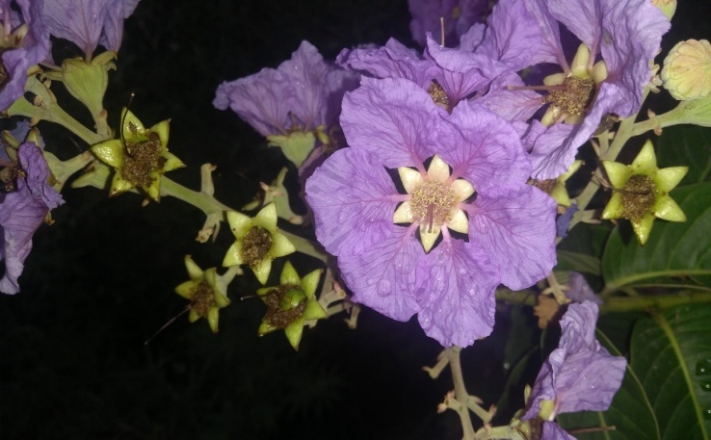
14. Lagerstroemia speciosa

Kingdom :- Plantae
Class :-Dicotyledons
Order :-Myrtales
Family :-Lythraceae
Genus :-Lagerstroemia
Species :-speciosa
Location :- Mall road , Major Aryan School , Ambala cantt.

Common name: - Pride of India, Queen Crape Myrtle, Banaba
- This tropical flowering tree is one of the most outstanding summer bloomers.
- It is called Queen Crape Myrtle because it's the Queen of the Crape Myrtles, dominating with grand size and larger, crinkled flowers.
- Lagerstroemia speciosa is a large tree growing up to 50' but it can be kept smaller by trimming.

Medicinal uses:
- Leaves are used in the Philippines as a folk medicine for the treatment of diabetes and kidney diseases.
- The fruit are used India to cure mouth ulcers.
- The roots are also considered astringent and the seeds narcotic.
- Banaba has a long history of medical usage and has a long list of folkloric health benefits for constipation, inflammation of kidneys dysuria and other urinary dysfunctions, blood pressurecontrol , kidney disorders, urinary dysfunctions (helps ease urination) controls the cholesterol levels, treatment of diarrhea, facilitates bowel movement, treatment of fevers and others.
- Banaba can affect blood sugar control. When taking Banaba herbal medicine, monitor blood sugar level and it is recommended to consult with your doctor.
- Banaba herbal medicine can lower the blood pressure level. It is best to monitor the blood pressure while taking Banaba herbal medicine for people with low blood pressure condition.
Precautions:
There are no sufficient studies done to investigate the adverse or side effects of Banaba herbal medicine during pregnancy and breast feeding. It is recommended to avoid its use.

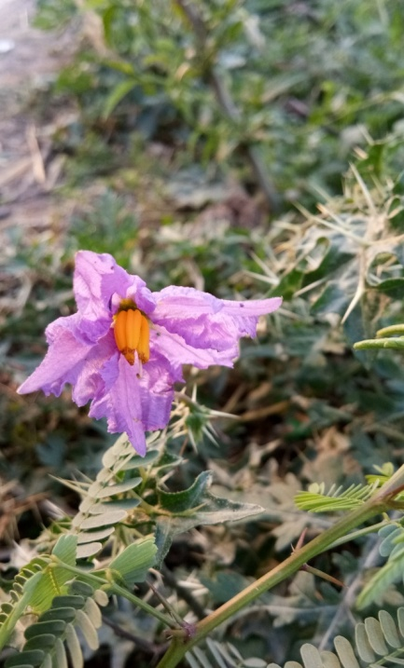
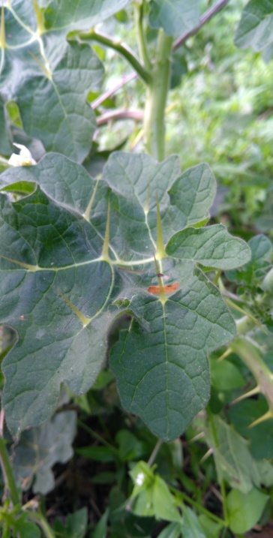
15. Solanum xanthocarpum
Kingdom :- Plantae
Class :-Dicotyledons
Order :-Polemoniales
Family :-Solanaceae
Genus :-Solanum
Species :-xanthocarpum
Location :- Mall road, Babyal , Mahesh nagar , patel park, Ambala cantt.
Common name: -Yellow-fruit nightshade, yellow-berried nightshade, Thai green eggplant, Thai striped eggplant, Kantakari.
- The ripe yellow fruits are around 3 cm in diameter.
- The plant has a shrub habit and is covered in sharp thorns which can be green or purplish.
- Flowers are typical of the solanum genus with five petals and can be white or purple with adnate yellow stamens emerging as a ring from the center.

Medicinal Properties
- Kantkari is used in Ayurveda, Siddha and Unani to treat variety of diseases. It is useful in treating worms, cough, hoarseness of voice, fever, painful urination, enlargement of the liver, muscular pain, and stone in the urinary bladder.
- In migraine, asthma and headache, leaves juice of kantkari is administered as nasal drops.
- The paste of whole plant is applied on swollen and painful joints in arthritis. This gives relief in the swelling and pain.
- The juice of berries is used in curing sore throat. The fruits of Kantkari plant are edible and used as folk medicines to treat throat infections and other inflammatory problems.
- A decoction of the fruits of the plant is used by tribal and rural people of Orissa, India for the treatment of diabetes. The fruits are eaten as an anthelmintic and for indigestion.
- Roots and seeds are used as an expectorant in asthma, cough and pain in chest.
- Take fresh kantkari leaves juice and massage on scalp to cure hair fall and dandruff.
- Take fresh leaves of kantkari and grind to extract juice. Now soak cotton in this juice and apply on tooth to relieve toothache.

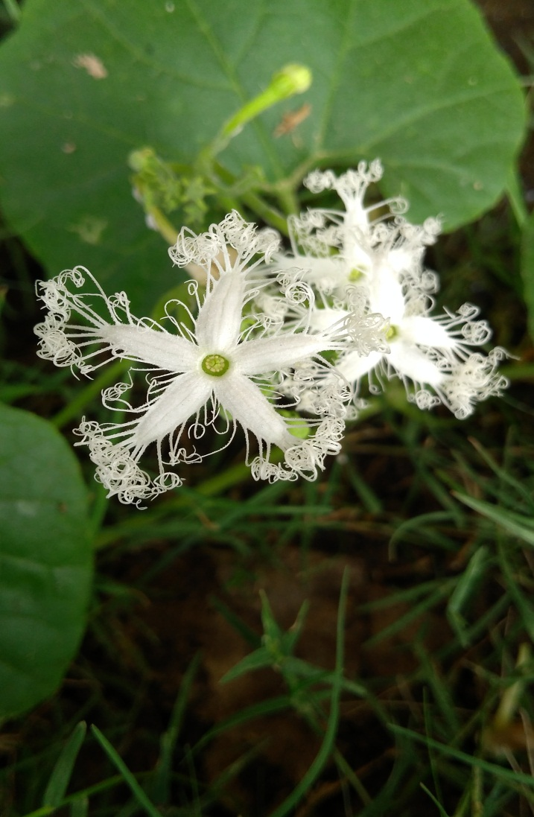
16. Trichosanthes cucumerina
Kingdom :- Plantae
Class :-Dicotyledons
Order :-Cucurbitales
Family :-Cucurbitaceae
Genus :-Trichosanthes
Species :-cucumerina
Location :-Babyal, Ambala Cantt.

Common name: Snake Gourd

- Snake Gourd is a tropical or subtropical vine, raised for its strikingly long fruit, used as a vegetable and for medicine.
- The narrow, soft-skinned fruit can reach 150 cm long. Its soft, bland, somewhat mucilaginous flesh is similar to that of the luffa.
- Leaf blade kidney-shaped or broadly ovate, 7-10 × 8-11 cm, membranous, deeply 5-7-lobed, lobes triangular or rhombic.
- The white flower is beautiful and lacy, and open at night.
- The shoots, tendrils, and leaves are also eaten as greens. It is a popular vegetable in South India.

Medicinal uses:

- According to Ayurveda, the plant pacifies vitiated pitta, constipation, skin diseases, burning sensation, diabetes, anorexia, flatulence, constipation, worm infestation, fever and general weakness.

- Snake gourd helps in the treatment of a variety of ailments such as fever, low immunity, diabetes, general debility, frequent urination, hair loss, obesity and skin diseases.
- Snake gourd is an excellent food choice for the patients with diabetes mellitus. It helps reducing blood sugar level by acting on insulin resistance. It increases the insulin efficiency that helps in reduction of elevated levels of blood sugar.
- Snake gourd is cholesterol free food and helps in lowering extra circulating cholesterol in the blood. Sometimes, elevated levels of cholesterol and triglycerides are responsible for the raised blood pressure. Snake gourds help to lower the blood pressure by reducing the cholesterol and cleansing the blood vessels.
- Snake gourd is also rich in potassium and low in sodium, so it is a favorite diet for the heart.
- Snake gourd is effective in jaundice, fever due to liver diseases and viral infections (hepatitis A, B and C). In Ayurveda, it is used along with coriander seeds.
- The leaves of snake gourd plant have antibacterial properties.
- The use of snake gourd helps in promoting growth of the hair follicles and hairs on the scalp, a recent study reveals this fact. Snake gourd has a potent action to promote hair growth and eliminate hair fall.
Side effects of snake gourd (Trichosanthes cucumerina)
- Snake gourd extract has anti-fertility effects in women. It can cause anti-ovulatory activity in females. One study has confirmed these findings in experiment on adult rats.
- However, snake gourd as vegetable is safe, but regular use of its extract by women may cause ovulation problems, so stay on safer side not to use extract during reproductive age.

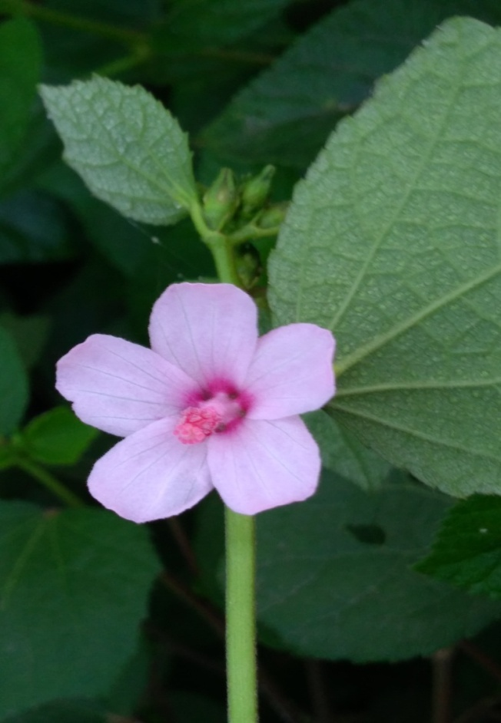
17. Urena lobata
Kingdom :- Plantae
Class :-Dicotyledons
Order :-Malvales
Family :-Malvaceae
Genus :-Urena
Species :-lobata
Location :-Babyal Road, Nirmal complex, Mahesh Nagar , Mall Road , Convoy park , Patel Park, Prachin Shiv Mandir , Ambala Cantt

Common Names
Aramina, bur mallow, Caesar weed, Caesar's weed, Caesar weed, Congo jute, hibiscus burr, pink burr, pink Chinese burr, pink-flowered Chinese burr, urena burr, urena weed.
- Each individual plant grows as a single stalk that freely sends out bushy stems.
- The leaf shape is palmately lobed (having lobes that spread out like fingers on a hand).
- Like the stem, the leaves also have tiny hairs. Flowers of the plant are pink-violet and grow one centimeter in width.
- The fruit is also hairy and may stick to clothing material or fur.

Medicinal Uses:-

- The plant is commonly used in traditional medicine, with the leaves and roots most commonly employed.
- The juice of the leaves or roots is used widely to treat bowel complaints, especially colic, stomach-ache, diarrhoea and dysentery, and also to treat gonorrhea and persistent fever from malaria
- A lotion made from the plant is used to treat yawns and headache.
- The whole plant is macerated and used externally for treating fractures, wounds, mastitis and snake bites.
- The roots are used to treat rheumatism and lumbago.
- The twigs are chewed to treat toothache.
- The bark is used to heal cuts.
- The flowers are considered maturative and are taken in decoction as a pectoral and expectorant in dry coughs.

References:
- Dastur, JF (1955): Medicinal Plants of India and Pakistan. D.B. Taraporevala Sons & Co. Ltd.
- Graves, George (1990): Medicinal Plants. Bracken Books London.
- Jain, SK (2012): Medicinal Plants. National Book Trust India
- Kaur, R. & B.D., Vashishtha (2014): Ethnobotanical Studies on Karnal District, Haryana, India. International Journal of Biological Sciences. Vol. 3(8), 46-55
- Kochar, SL (2011): Economic Botany in the Tropics. Macmillan Publishers India Limited
- Pamplona-Roger, George D.(2004): Encyclopedia of Medicinal Plants. Vol. I and II. Home Health Education Services.
- Sharma, Meghender & Kumar, Ashwani (2013): Ethnobotanical uses of medicinal plants: A Review. International Journal of Life Science and Pharma Research. Vol 3 / Issue 2. 52-57
- http://tropical.theferns.info/viewtropical.php?id=Urena+lobata
- https://herbpathy.com/Uses-and-Benefits-of-Lagerstroemia-Speciosa-Cid5752
- http://www.flowersofindia.net/catalog/medicinal.html
- https://en.wikipedia.org/wiki/Medicinal_plants

